**SCALABILITY AND HIGH AVAILABILITY**

**SCALABILITY**

Scalability means that an application/system can handle greater loads by adapting.

There are two kinds of scalability:

Vertical and horizontal

Scalability is linked but different to high availability

**VERTICAL SCALABILITY**

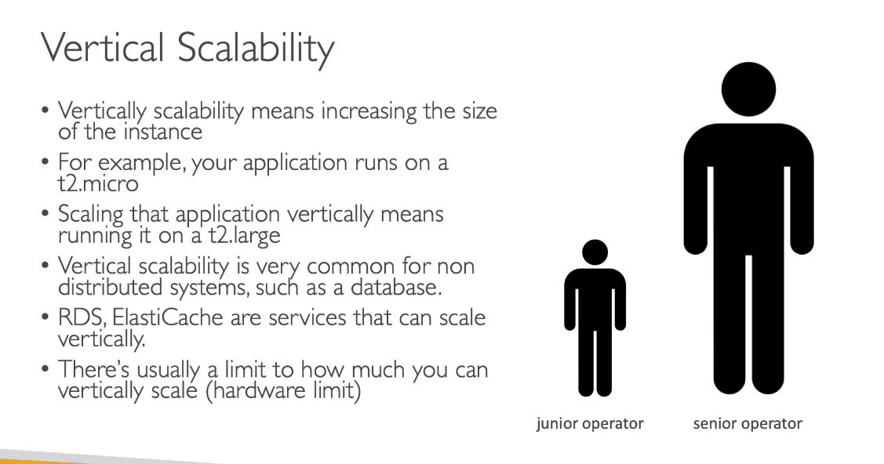

**HORIZONTAL SCALABILITY**

**HIGH AVAILABILITY**

**HIGH AVAILABILITY AND SCALABILITY FOR EC2**

